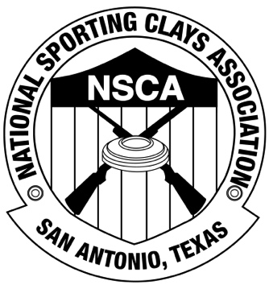

**APPLICATION**

**NSCA LEVEL II INSTRUCTOR COURSE**

Name_______________________________________________________ NSCA #______________________

Address___________________________________________________________________________________

City_________________________________________________State_______________Zip_______________

Mobile Phone ______________________ e-mail _________________________________________________

Current NSCA Class _______ Highest NSCA Class ever earned ________

NSCA Lifetime Registered Targets (available in your online profile) _____________

How long have you been a Level I Instructor? _______ years, ______ months

How many documented instructional hours do you have AS A LEVEL I Instructor*? ________

* (must be “clock hours”, i.e., two hours teaching three students counts as 2 hours, not 6 hours)

Have you ever taken lessons from a Level II or equivalent sporting clays instructor before? ________

From whom? _____________________________ Total # hours? _________

Where? / When? _________________________________________________

Course location & date you are requesting: _____________________________________

Costs: $750.00 (Three day course). Payment is due 21 days prior to the course date. You will also be responsible for the following additional costs: your personal target fees at the host club, the certifying instructor’s expenses (each candidate will pay an equal share of the certifying instructor’s expenses).

Please bring: Shotgun, 250 rounds of ammunition, eye protection, ear protection, shell pouch and/or vest, three-ring binder (for handouts) and printed course manual (on-line). Please go to [www.nssa-nsca.org](http://www.nssa-nsca.org) and download the Level II instructor manual to study.

**Complete this application and e-mail, fax or mail with your $750.00 Registration fee to**:

Lori Hartmann

NSCA Instructor Certification

5931 Roft Road

San Antonio, TX 78253

Ph. 210-688-3371 ext. 116

Fax 210-688-3014

[lhartmann@nssa-nsca.com](mailto:lhartmann@nssa-nsca.com)

Form of Payment (check one): Check ________ Credit Card (Provided below) _______

MC/Visa/AmEx/Disc.# :______________________________________ Exp. Date ___________

Security code on front or back of card: ___________________

NATIONAL SPORTING CLAYS ASSOCIATION

5931 ROFT ROAD • SAN ANTONIO, TEXAS 78253-9261 • (210) 688-3371